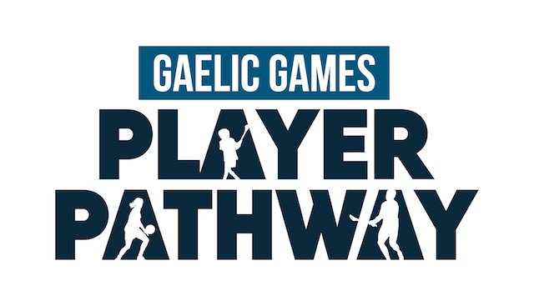

NUACHT RÁITEAS | MEDIA RELEASE

16ú Márta, 2021

The GAA, the LGFA & An Cumann Camógaíochta launch new Gaelic Games Player Pathway
https://www.youtube.com/watch?v=ytswTVtQYo4

The GAA, the Ladies Gaelic Football Association & An Cumann Camógaíochta are delighted to announce details of a new and exciting Gaelic Games Player Pathway.

For the first time, all three Associations with responsibility for the promotion of Gaelic Football, Hurling, Ladies Football and Camogie will have an aligned pathway and vision for player development.

All players are at the heart of this new Pathway – with club involvement central to its success – and there will be a key focus on creating an effective player development environment.

The Gaelic Games Player Pathway aims to fulfil the mission of the three Associations to address elitism in underage development, make quality coaching within clubs a lynchpin and to provide an opportunity for lifelong participation in our games for every boy and girl, regardless of their ability.

The Pathway has three main phases: Foundation, Talent and Elite/High Performance, with these phases further subdivided into eight sub-phases.

All three Associations are committed to providing players with the right supports at the right time, which will enable them to individually empower themselves to engage with the many challenges they will face along their Player Pathway Journey.

Kilkenny hurling legend Henry Shefflin (Ballyhale Shamrocks) was on hand today to launch the new Player Pathway, along with Kilkenny Senior camogie player Davina Tobin (Emeralds), and Meath Senior Ladies Footballer Vikki Wall (Dunboyne).

This announcement reinforces the commitment and joint approach to Games Development from all three Associations, and builds on previous collaborations such as Go Games, Féile, Volunteer Training, the recently-launched ‘Be Ready to Play’ and the Introduction to Coaching Gaelic Games Course, which will be launched very soon.

The Pathway outlines a holistic approach to Player and individual development, with the overriding aim of providing all players with positive experiences, thereby increasing the retention rate of lifelong participants.

The GAA, the Ladies Gaelic Football Association & An Cumann Camógaíochta are united in the wish to create a better understanding of the Player Pathway for all involved in nurturing a love of Gaelic games – the player, the parent/guardian, the coach, the club, the teacher.

Speaking about today’s launch, Uachtarán Chumann Lúthchleas Gael, Larry McCarthy, said: “The Gaelic Games Player Pathway is the result of several years of careful work and planning that is designed to give every player the chance to have the best experience possible from their involvement in Gaelic games.

“All of our players are club players; and so it is vital that we put the club at the heart of our player development pathway and ensure that whatever road your playing career takes, that it is something positive and that the club in turn benefits. Aligning this work across the GAA, LGFA and Camogie will embed this philosophy throughout Gaelic games coaching with a culture that nurtures the Person as much as the Player.”

Uachtarán Cumann Peil Gael na mBan, Mícheál Naughton, commented: “This exciting programme will help greatly to foster and enhance a culture of participation and enjoyment for all of our players.

“Our wish is that our players get involved in our Association and stay involved for life.

“You may be a player who is fortunate to line out for your county on All-Ireland Final day – or you may be a player who’s in our sport simply for participation and enjoyment.

“There is no distinction to be made here – it’s about playing our sport because you enjoy it, and being encouraged to play.

“I would like to acknowledge the hard work and collaboration of key stakeholders in all three Associations in bringing this Gaelic Games Player Pathway to fruition.”

On behalf of An Cumann Camógaíochta, President Kathleen Woods commented: “The Camogie Association is delighted to be part of this historical and ground breaking collaboration.

“The core and heart of this new pathway is that it is player-centred and club-centred.

“This new pathway facilitates the development of all players at all levels from participation to performance.

“The underpinning philosophy of the Gaelic Games Player Pathway is to support players with the right environment, at the right time of development through coaching, education and developing their athletic and personal capacities as they grow.

“This will ensure that the experience of playing our games is always appropriate for the developmental stage of the player involved and will assist players, parents, coaches, teachers officials and administrators to make informed decisions about player development so that every child youth and adult can reach their desired potential and enjoy our games throughout their lifetime.

“I would like to acknowledge and thank the work of the staff within all three associations and the many volunteers who have contribute to the Gaelic Games Player Pathway Development.”

For full details on the Gaelic Games Player Pathway, visit https://learning.gaa.ie/playerpathway

For further information, contact:

Shane Flanagan, GAA Director of Games Development: shane.flanagan@gaa.ie

Lyn Savage, National Development Manager, LGFA: lyn.savage@lgfa.ie

Louise Conlon, Technical Development & Participation Manager, Camogie Association: louise.conlon@camogie.ie

Ends

